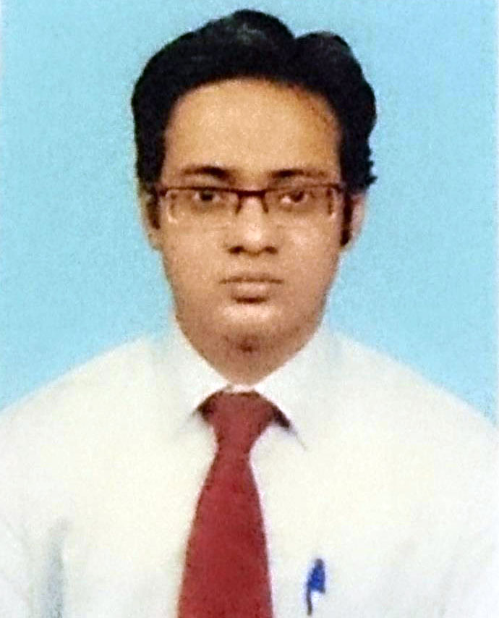

CURRICULAM VITAE

NAME: Mr. Sridipta Bhaumick

FATHER’S NAME: Dibyendu Bhaumick

ADDRESS FOR COMMUNICATION: Bhaumick house,p.o & vill-mallikpur via malancha mahinagar,p.s-
Baruipur . Dist-24 parganas(s). kolkata-700145. West Bengal

PHONE NO: +91 7044765077

DATE OF BIRTH: 23rd November, 1988

E-MAIL ID: sridipta21bhaumick@gmail.com

CAST - General SEX: Male

QUALIFICATION

Exam Passed | University/Institution | Year of Passing | Class/Div. | % of Marks/CGPA
I.C.S.E. | I.C.S.E. | 2004 | 1st Div. | 68
I.S.C. | I.S.C. | 2006 | 1st Div. | 71
B.Com (Hons.) | University of Calcutta | 2009 | 2nd Div. | 57
MBA(Banking & Finance) | Manipal University , Karnataka | 2013 | 1st class | 7.00

PROFESSIONAL QUALIFICATION

Last Employer – ICICI Bank Limited

Work Experience – 3 years 7months

Designation – Deputy Branch Manager

Last Salary – 4.3 lacs CTC

Skills -
- Team Management
- Client Management
- Operations Management
- General Administration
- Analyical Skills
- Interpersonal Skills
- Problem solving skills

Roles and Responsibilities-
- Ensuring that the financials of the branch are control and the branch adheres to the know your customer (KYC) and anti money laundering (AML) norms at all times
- Start to end vigilance on GOLD LOAN of the branch including customer acquisition,providing training to junior staffs,appraising,vault and adherence to audit and compliance asper Bank norms.
- Providing advisory services to corporate & high net worth customers on funds management while maintaining relationship with key accounts
- Responsible for dealing with external and internal auditors and inspections and compliance.
- Supervising key areas including marketing, business channel development, team development, cost management, revenue generation.
- Monitoring the branch sales targets,conceptualizing & implementing competent strategies in coordination with the branch and the sales team with a view to penetrate new accounts and expand existing ones for a wide range of financial products & services
- Looking after branch CASA generation and profitability and also responsible for branch customer servicing . Ensuring that customer requests are accomplished within commotted TAT and solving critical customer complaints and generating high Feedback On Customer Service (FOCUS) score for the branch.

LANGUAGES KNOWN:English,Bengali,Hindi

I hereby declare that the informations furnished above is true to the best of my knowledge

-------------------------------------------

SRIDIPTA BHAUMICK

